Message transformation and routing without a common data model (CDM)

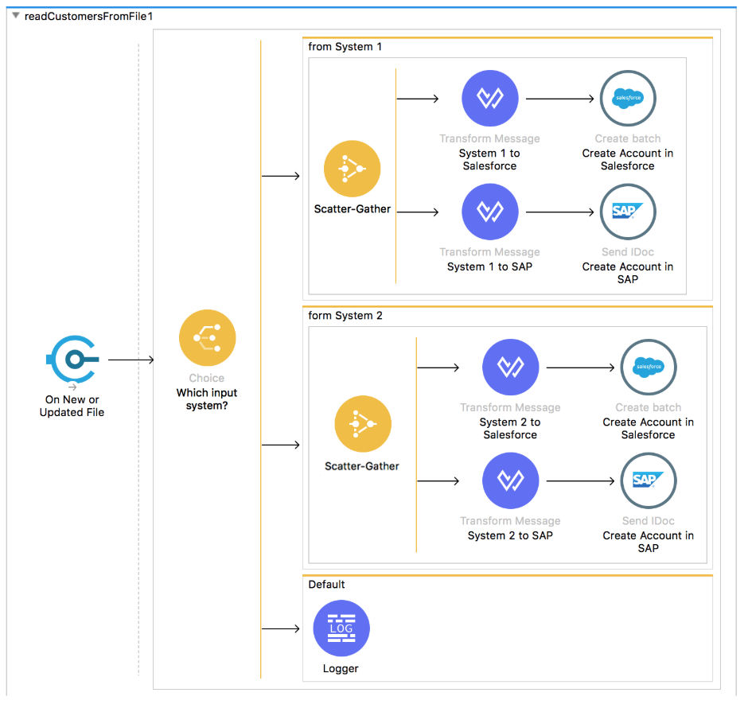

Message transformation and routing mediated with a common data model (CDM)

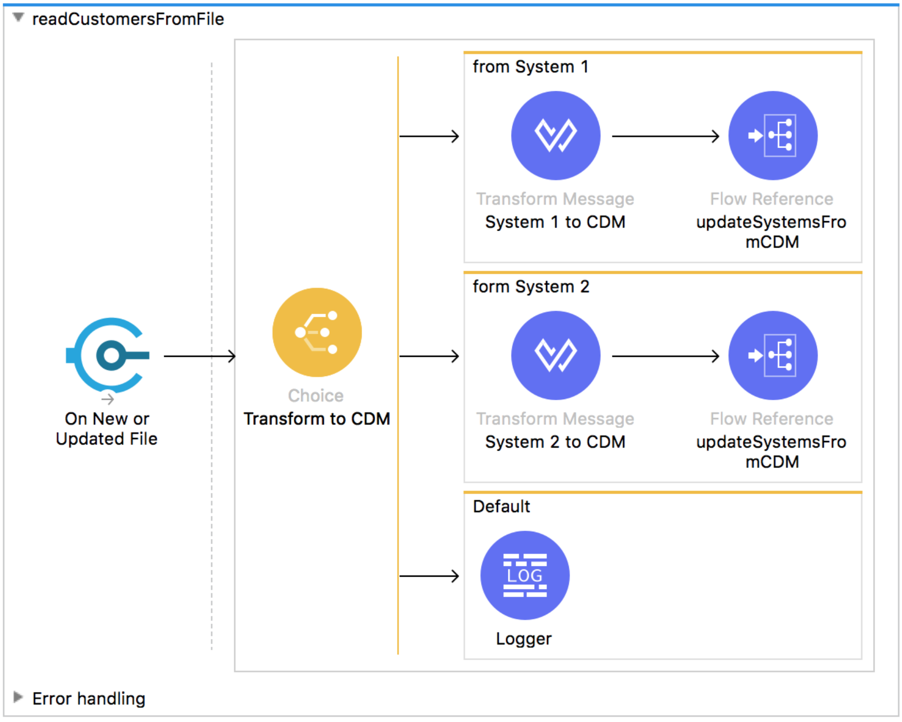

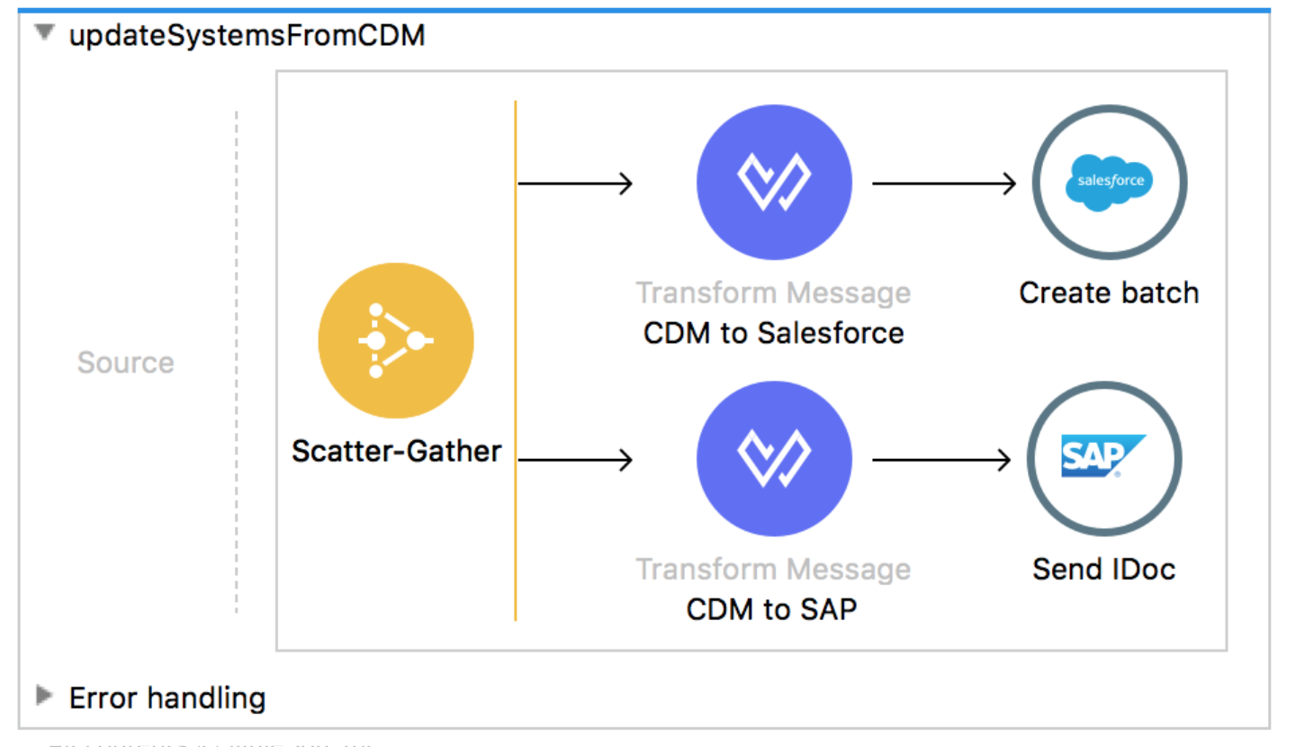

Adding a third endpoint is now decoupled (isolated) from the CDM data transformation step.



